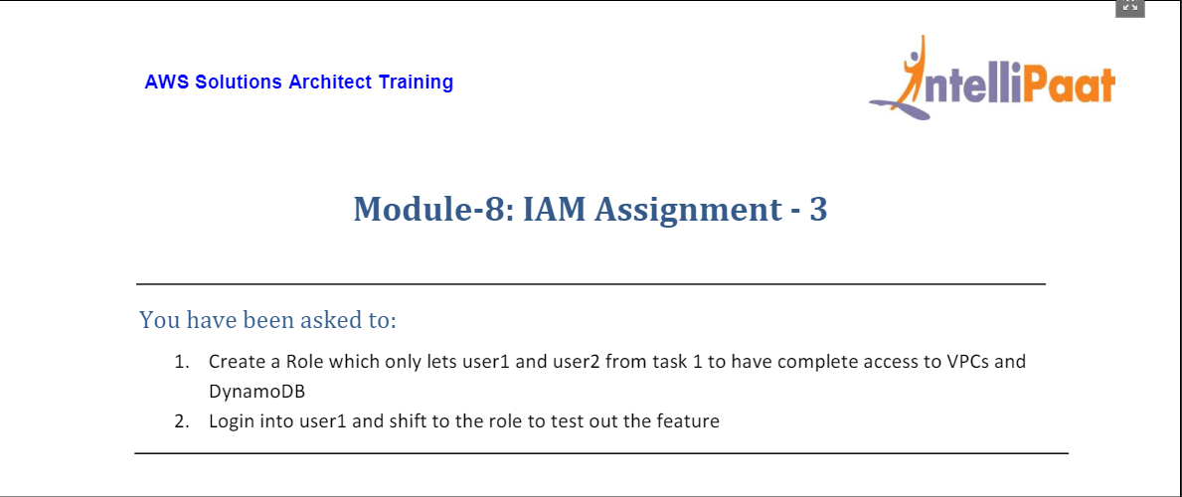

1. From IAM Dashboard, you can choose role on LHS and then click on Create Role on RHS.

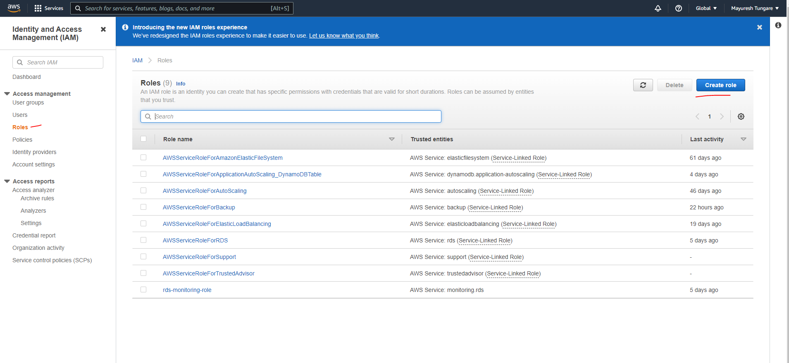

1. On the next screen, select Another AWS account and provide your own Account ID.

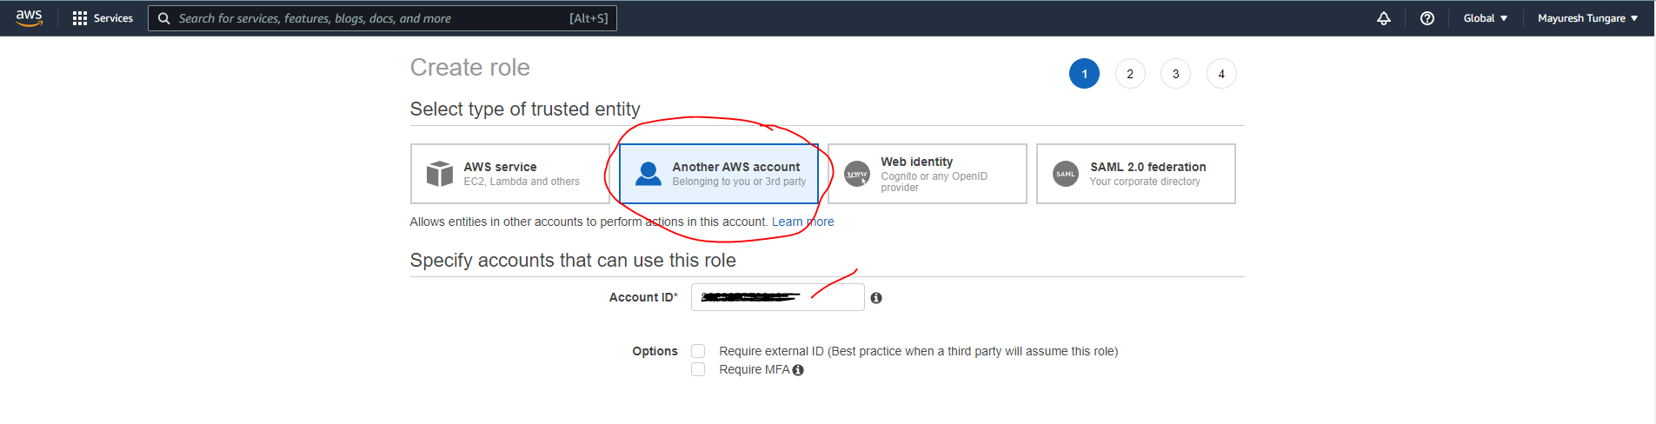

1. On next screen, search for VPC and select VPC Full Access

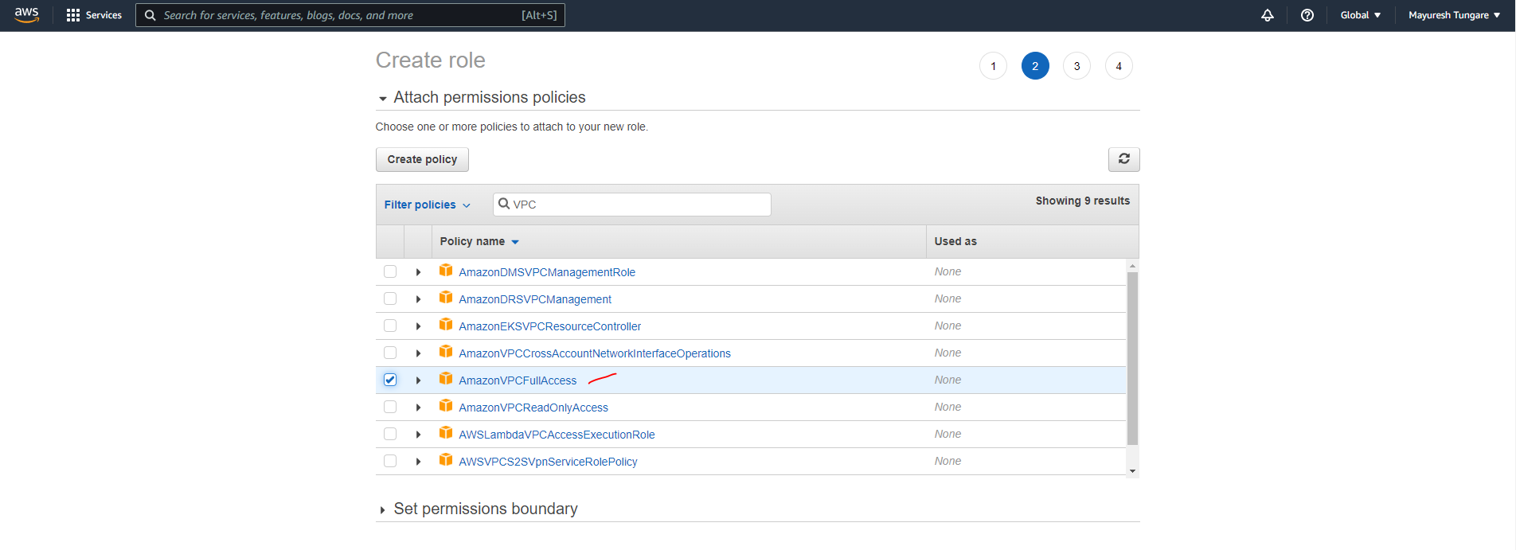

1. Next, we choose DynamoDB Full Access as shown below:

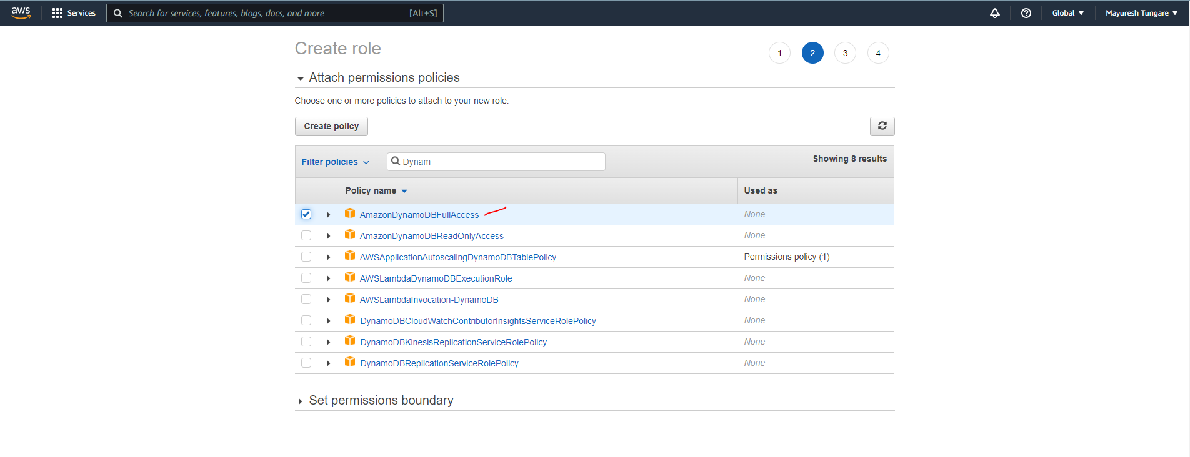

1. Add tags to identify the role.

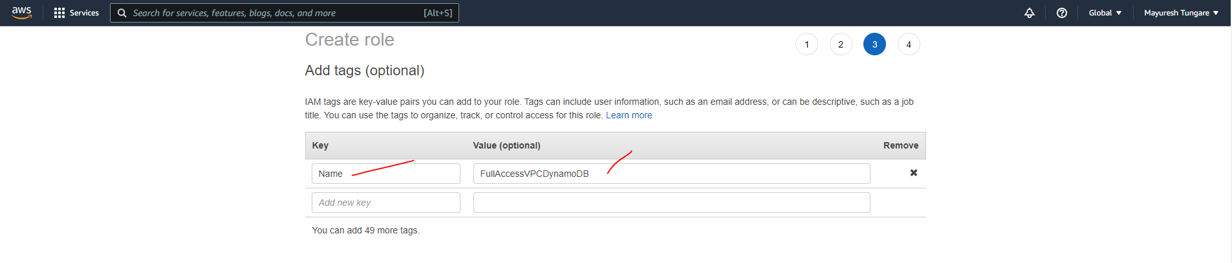

1. Finally enter all the required data as below:

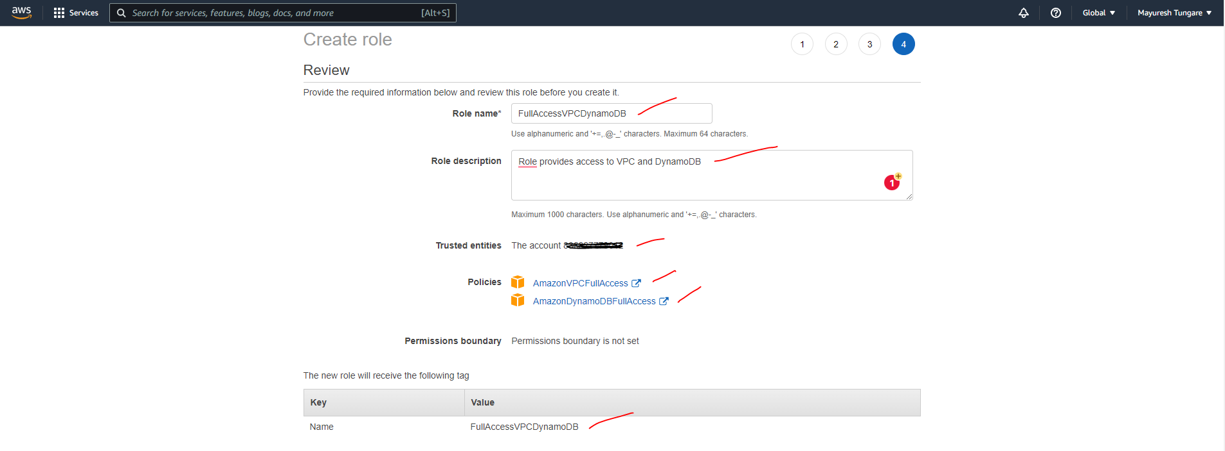

1. Next, we see the role has been created.

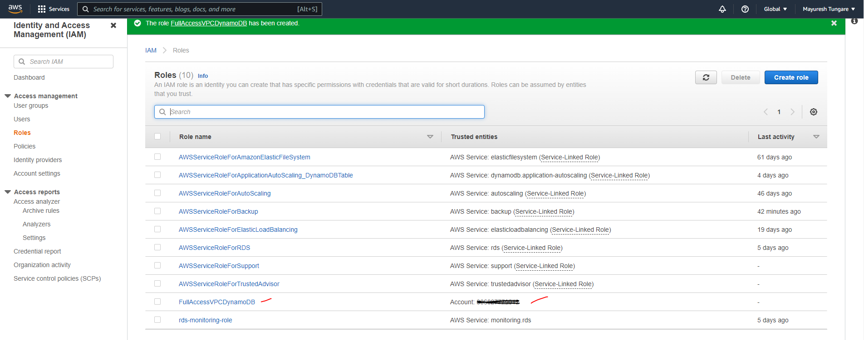

1. Now we add the role to user1 and user2. For that head to the role and go to Trust relationships tab. Currently you will see your account number there. You can click to

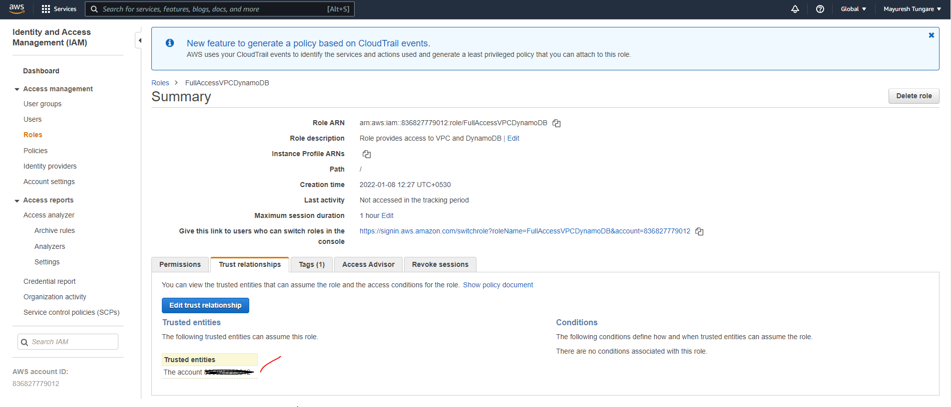

1. We use the user ARNs to add to Trust Relationship

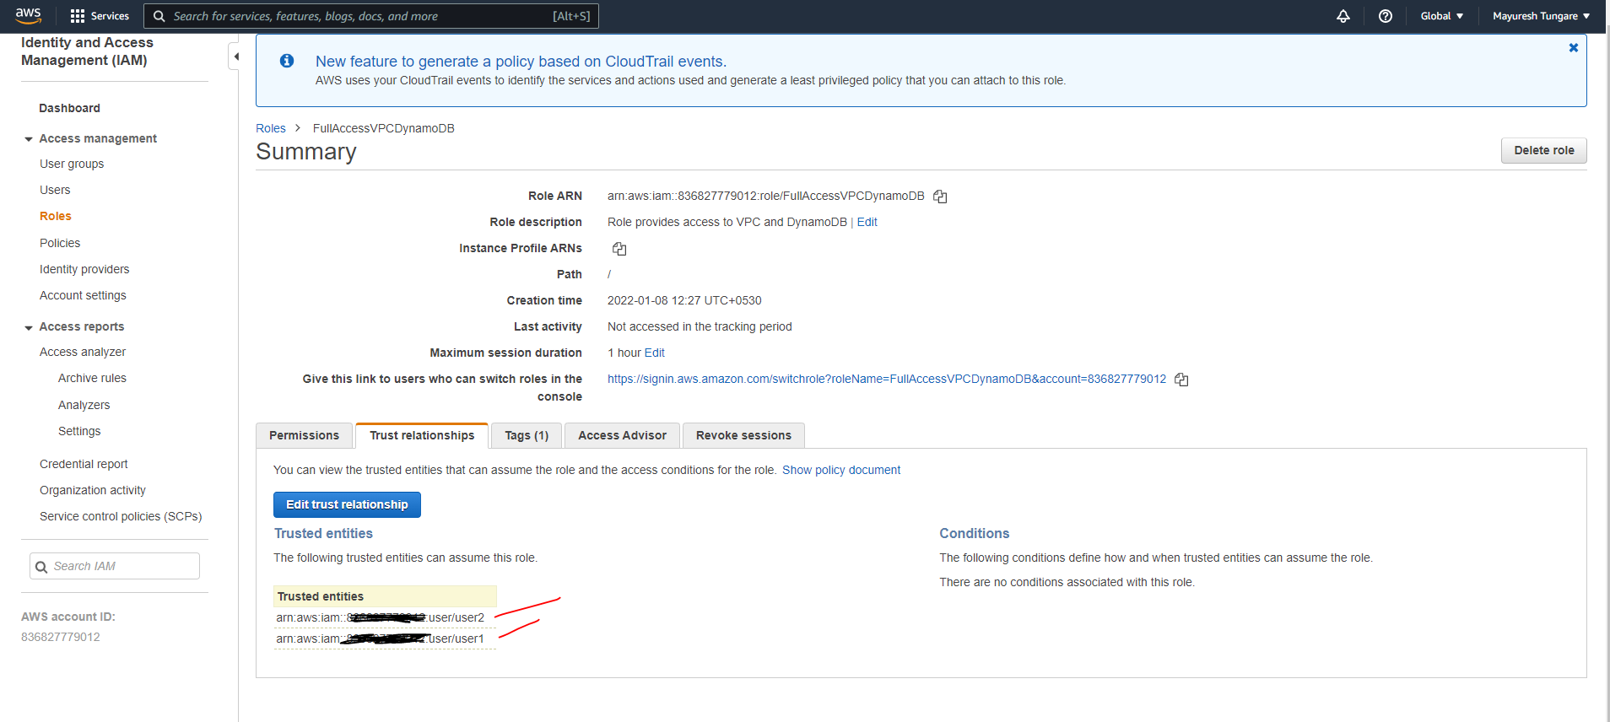

1. Now we login into user1 to check if we can assume the role. The snapshot below confirms that user1 can assume the role. We logged into user1 and could launch the VPC launch wizard.

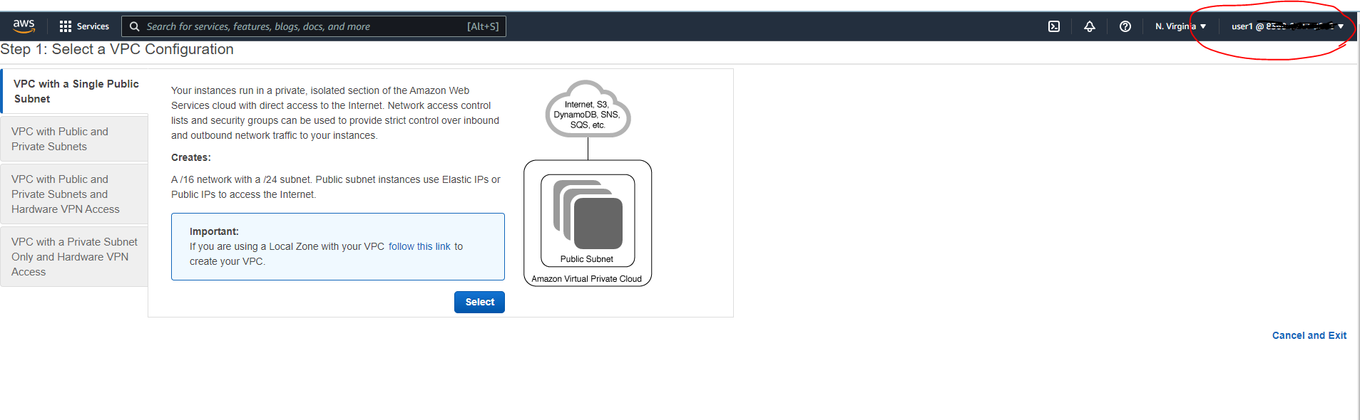

1. Thus, this assignment is now complete.